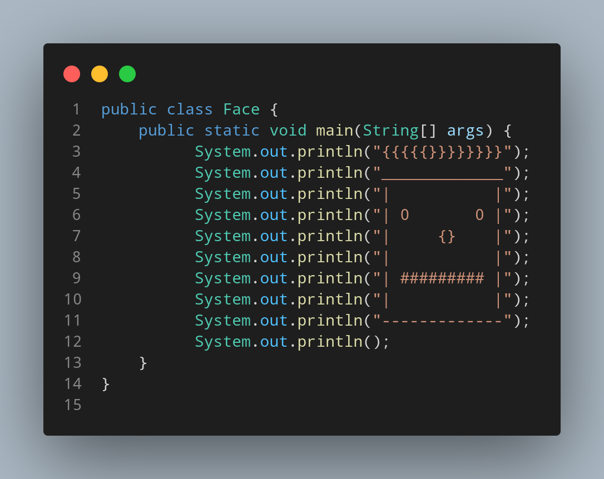

#Doc

File name Face is created so we create a class name Face, inside the class we created a main function. The main function only contain print function that print the spaces and symbols that are structured like face to print big face made up of symbol and space.

